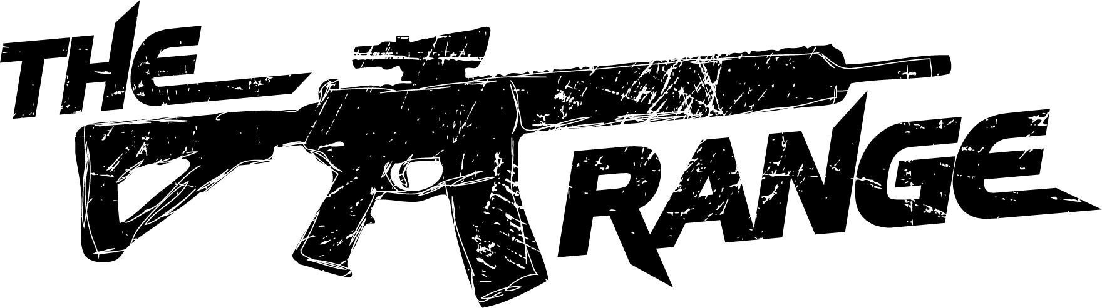

Range Rules & Waiver

If you are ineligible to own a firearm, you may not use the range.
If you are pregnant, DO NOT SHOOT. Noise and lead are a hazard.

Your Information
Name:
Address:
City: |  |  |  |  | State: |  |  |  | Zip Code:
Phone #: |  |  |  |  | Date of Birth:
Driver License #: |  |  |  |  |  |  |  | Expiration Date:
If you would like to receive updates on our upcoming events & classes please enter your email address.
Email:
Concealed Carry Permit: |  |  |  | Circle YES NO |  |  | Expiration Date:

Please check each line as you read it and agree to it
All shooters will obey the basic rules of firearms safety:
- TREAT ALL GUNS AS IF THEY ARE LOADED
- NEVER POINT A GUN AT ANYTHING YOU DO NOT WANT TO SHOOT
- KEEP YOUR FINGER OFF THE TRIGGER UNTIL YOUR SIGHTS ARE ON YOUR TARGET
- KNOW YOUR TARGET AND THE BACKSTOP BEYOND
Alcohol and drug use are strictly prohibited. This includes Marijuana. Marijuana use is illegal under federal law and makes the user ineligible for firearms possession, purchase, or use.
Hearing and Eye protection must be worn at all times on the range, even when you are not shooting.
Personal firearms must be unloaded and in a case, open carried or concealed carried with a valid permit. DO NOT UNHOLSTER A CARRIED FIREARM OF ANY KIND WITHOUT IT BEING INSIDE OF THE RANGE AREA AND AFTER NOTIFYING THE ON DUTY RANGE SAFETY OFFICER OF YOUR INTENT TO UNHOLSTER.
ABSOLUTELY NO HANDLING OF FIREARMS ANYWHERE OTHER THAN INSIDE THE RANGE
Muzzles will be pointed downrange at all times and never higher than the target. Firearms must remain in the stall with you. Do not move firearms between stalls, if sharing please move people not firearms.
Unaimed and uncontrolled fire is strictly prohibited. This includes intentional and unintentional firing. ANY SHOT STRIKING AN OVERHEAD BAFFLE WILL RESULT IN A $40 FINE. DAMAGE TO EQUIPMENT WILL RESULT IN A FINE EQUAL TO REPLACEMENT COST OF THE DAMAGED EQUIPMENT. All damage must be reported to the on duty Range Safety Officer. Failure to report will result in loss of range use.
Ammunition larger than .308 is NOT allowed unless you ask the on duty Range Safety Officer. EVERY TIME.
Only FMJ (full metal jacket) TMJ (total metal jacket) JHP (jacketed hollow point) or JSP (jacketed soft point) are allowed. No incendiary rounds of any kind. NO EXCEPTIONS.
CONTINUED ON THE OTHER SIDE!

Rental firearms
All rental firearms entering or leaving the range area must be unloaded, with actions open, and a safety flag or chamber flag in the chamber
If firing a rental firearm, only range ammo is allowed.
Please contact the Range Safety Officer if you have any questions or issues regarding the rental firearm

range etiquette
Only one person may fire from the shooting stall at a time.
Never cross the firing line. Brass that goes forward of the line may not be retrieved. Anything behind the line can be retrieved. Please keep your stall policed of casing, it is a tripping hazard. Squeegees are provided on the back wall for your use. Push or move loose casings forward of the firing line if you are not retrieving them.
No food or beverages in the range area, other than water.
Safety is our priority: If you see something that needs attention, take action and tell a Range Safety Officer immediately!
Children under the age of 7 are not allowed in the range area. Age 7 to 18 must be accompanied by an adult.
Remember to wash hands and face after firing. Components of ammunition may contain lead. Wipes are provided in various areas in the range and at the range check in counter
Drawing from the holster is not permitted without qualifying credentials on file.
Clip targets to the backer in a way that keeps your aim in the middle of the room and off the baffles and floors.
No open toed shoes or low cut shirts.

I agree that I will assume full responsibility for any and all injuries, losses, or damages which occur to me and or my family while on the premises of The Range and to the maximum extent allowed by law I agree to release, indemnify, and hold harmless The Range, LLC or any employee from any liability whatsoever for injuries, losses, or damages. I agree that I will indemnify and hold harmless to the maximum extent allowed by law, from costs (including legal fees) injuries, damages, losses, or liability to third parties from claims asserted against the companies or any employee arising from my conduct and or the conduct of my family or other guests.

Signed Date

Thank you for visiting our range. Our employees have unquestionable authority regarding operations and safety. Please obey their instruction without hesitation. Their major focus is your safety. If you have any questions please ask any of our staff.

This section to be completed by a RANGE EMPLOYEE only

Safety Video Watched

Date: Employee Initials

